- The average number of key comparisons done in a successful sequential search in a list of length n is:
- log n
- (n-1) / 2
- n/2
- (n+1) / 2

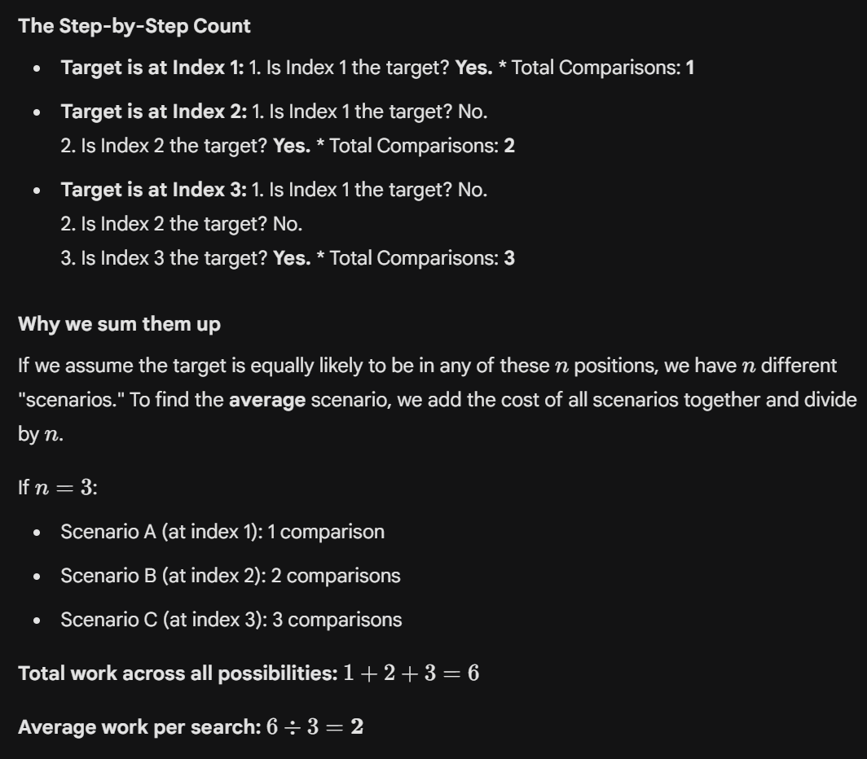

- Based on the definitions of asymptotic notations, the average-case time complexity of binary search is:
- Ω(n log(n))
- Ω(log(n))
- O(log(n))
- O(n log(n))

- C is correct
- B and C are correct
- B, C and D are correct
- A, B and C are correct

- Consider the python codes given below. Assume that the array listA contains n(>0) elements, sorted in ascending order.
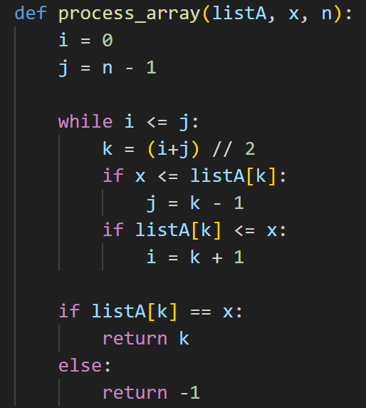
Which one of the following statements about the function ProcessArray is correct?
- It will run into an infinite loop when x is not in listA.
- It is an implementation of binary search.
- It will always find the maximum element in listA.
- It will return -1 even when x is present in listA.

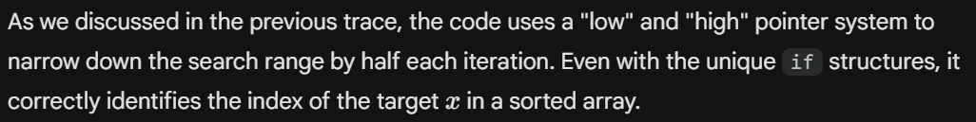

- Based on the definitions of asymptotic notations, the worst and average complexity of sequential search are:
- θ((n+1)/2) and Ω(n log(n)) respectively
- θ(n) and O(n) respectively
- Ω((n-1)/2) and O(n) respectively
- θ(n) and θ(n) respectively

- D is correct
- C and D are correct
- B, C and D are correct
- A, B, C and D are correct

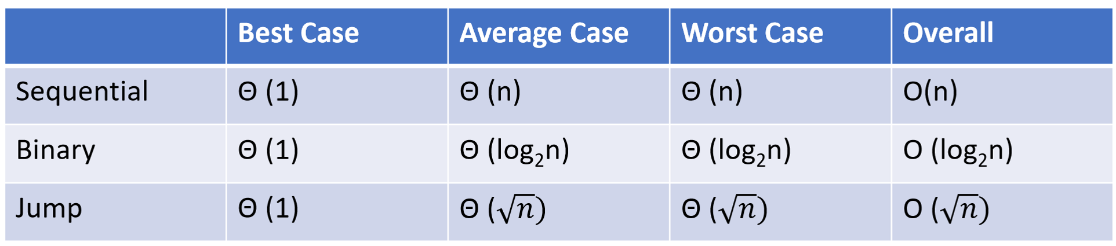
- Consider a sorted array of n numbers. What would be the time complexity of the best known algorithm to find a pair ‘a’ and ‘b’ such that |a-b| = k, k being a positive integer.
- O(n)
- O(n log n)
- O(n^2)
- O(log n)

